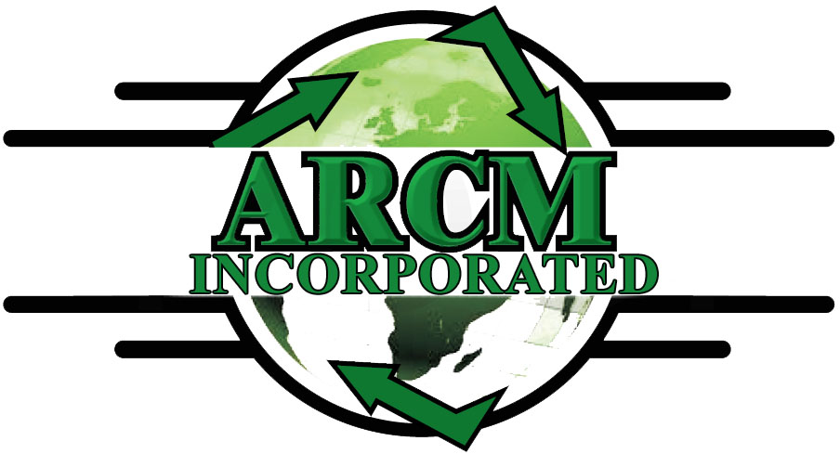
999 Wadsworth Blvd, Lakewood CO 80214 Telephone 303-306-8334 Fax 303-747-7760
www.arcminc.com

Mortgage Company Authorization Form
[ACTFIELD]TBL_CONTACT.CUST_DateofLead_025748561
1st Mortgage Company ______________________________________ Loan # ____________________________
2nd Mortgage Company _____________________________________ Loan # ____________________________
Fax # Phone #

Customer:
Address:
City State Zip:

Insurance Company Name:
Insurance Claim #:
Date of Loss: _________________

Borrower Authorization:
The undersigned hereby authorize mortgage lender to provide/release the following information to, and work directly with contractor on connection with the processing and payment of the claim (including draw status) as indicated below: (Initial All That Apply)

______ Authorization for Contractor to request inspections

______ Authorization to release claim information to Contractor

______ Authorization for Mortgage Lender to work directly with Contractor in connection with all aspects of processing and completing the payment of the claim

______ Authorization for Mortgage Lender to release payment drafts or draws payable solely to contractor

______ Authorization for Contractor to obtain check endorsement from Lender

Borrower’s Signature _____________________________________________ Date _______________

Co-Borrower’s Signature __________________________________________ Date _______________

